Image | 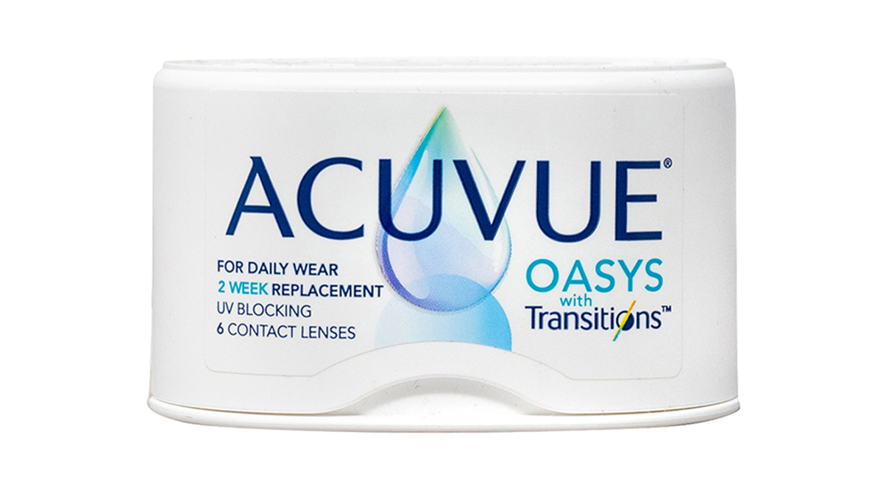
Brand | GUCCI
Model Name | acuvue-oasys-transitions2
Price | RS 1200
PRODUCT DETAILS

